University of Connecticut

MS in Business Analytics and Project Management



OPIM 5641 Business Decision Modelling

A Student’s Dilemma: Rent Or Buy?

Professor Cuihong Li

Team 8

Achyuth Sankineni

Julia Tremblay

Biheng Yang

Ziyi Zhao

Executive Summary

Scott and four other students are looking to live together in a house close to campus that has five bedrooms and at least two bathrooms. Scott has four options - she can purchase a house and rent rooms to her four roommates with inclusive or non-inclusive rent or she can rent a bedroom in one of two houses that offer inclusive and non-inclusive rent with her four roommates. If she chooses to purchase the house she will have $49,534.08 in her bank account if she inclusively rents to her roommates and $44,782.45 if she rents non-inclusively. If Scott chooses to rent with her four roommates, she will have $7,115.22 if rented inclusively and $8,613.95 if rented non-inclusively. All in all, we recommend she buys the house and rents inclusively to her roommates because she has the largest remaining bank balance after three years compared to the other options. We prioritized monetary value because it is something we can calculate to identify the difference between renting and buying. If Scott wants to prioritize non-monetary values such as stress and grades, yet chose the option that gives her the most money in the end, she would choose to rent non-inclusively.

Problem Description

We need to analyze the costs and benefits of buying a house and renting the property to conclude whether it would be profitable to purchase the house. To do so, we need to calculate the total rent she will pay over three years (either renting the inclusive or non-inclusive property) and the balance in her bank from the money not spent on rent that is earning 1%. In addition, we will need to calculate the monthly rent for the 4 students for Scott to break even if she buys the house. We will find out the cost she will have to charge the students for rent inclusively and non-inclusively to see where see has the larger bank balance. We also must take into consideration the profit she could potentially get if she sold after three years.

Important factors and costs to take into consideration when buying the house are: a down payment of at most $50,000 including $25,000 of her own and $25,000 from her parents, annual property tax (1.4427% of the house value and increasing with higher house prices), annual

insurance of $1200, maintenance costs of $6000 for three years, three years closed mortgage with 3.95% interest rate over 25 years (if she puts 20% down), utilities would be $130/month for hydro and gas that are adjustable by season: $195 from November to February and $65 from May to August, $120/three months for water heater, and an additional 20% costs of utilities if inclusive, internet and cable will be $70 monthly for 8 months (1 year with 4-month-empty-house), the house prices are expected to increase 2% annually, and the real estate agent would charge a 5% commission fee of the final price.

If Scott rents non-inclusively it will cost $435/month and she will have to split the cost of utilities with her four other roommates which include: heat at $120 every 3 month, hydro at $100 every month, and water at $30 every month. If Scott rents inclusively it will be $510/month, therefore the landlord will pay for utilities.

Scott is solely responsible for any expenses and issues with the house because she will be the owner. It is of concern to Scott that the time and effort to take care of the house may not be worth the profit. Will she also be able to maintain good grades if she is spending time on the accounting and house issues? Scott can’t sell the house until the end of three years - so there is no backing out. The students’ rent per month can’t be more than $550 each if Scott purchases the house because they agreed they wouldn’t pay more than $550 for the rental property.

Analysis

Part 1 Base-Case Analysis

There are four outcomes represented in our base-case model. It includes non-inclusive and inclusive rent if the five roommates choose to rent and it also includes non-inclusive and inclusive payments if Scott decides to purchase the house. There are assumptions we made when buying a house based off previous year values, such as the annual property tax in London of 1.4427% and house prices in London increasing by 2% annually. By using the base case we can analyze our results by looking at an optimistic and pessimistic outcome by fluctuating the property tax and annual house increase(or decrease). Assuming she will charge$510 for non-inclusive and $435 for inclusive in this base case.

Best or Worst Scenarios

(i) House Price Increase Rate: The current increasing rate 2%. Our research shows the increasing rate of house prices during 2012 and 2015 ranged from about -2% (pessimistically) to 10% (optimistically) (Appendix 1)

Inclusive: If Scott charge inclusive rent for $510, with current rate her balance is $49534.08. Optimistically, the balance increases to $109922.25, and pessimistically, the balance decreases to $22701.85. (Appendix 2)

Non-inclusive: If Scott charges non-inclusive rent for $435, with current rate her balance is $44782.45. Optimistically, the balance increases to $105170.62; pessimistically, the balance decreases to $17950.22.

Based on the values, the fluctuations in house prices increase rate have a significant impact on the final balance. Therefore, when buying and selling a house, knowledge related to the market should be researched and considered: for example, lower interest rates and higher economic growth are potential reasons for higher house prices.

(ii) Property Tax

Similarly, the property tax may change over time, but will not be as intense. The base Property Tax is 1.4427%. Assuming the optimistic tax rate is 1% and pessimistic tax rate is 2%.

Inclusive: If Scott charge inclusive rent for $510, the base tax brings her a balance $49534.08. Optimistically, the balance increase to $52822.12; Pessimistically, the balance decrease to $45394.87.

Non-inclusive: If Scott charge Non-inclusive rent for $435, the base tax will bring her a balance $44782.45. Optimistically, the balance increase to $48070.49; Pessimistically, the balance decrease to $40643.24.

Based on the values, even if the changes in property tax are small, their impacts on balance is significant. Therefore, before making decisions to buy or sell a property, Scott should have a brief understanding of the tax rate policy and possible future trends.

Part 2 Break Even Analysis (Appendix 3)

In addition, in order to choose a plan with the highest balance, she needs to know the breakeven point, at which the final balance equals when buying and renting. If Scott buys a house and then rents with an Inclusive plan, the breakeven rent charge is $230.188 for each person per month. If she rents rooms to her roommates with an Non-Inclusive plan, the break even rent charge is $187.68 for each person per month.

Knowing this, if she buys a house and charges the rent higher than these two values, she will have a higher balance of buying than renting.

Part 3 Optimization Analysis (Appendix 4)

Local Optimization: When we ran our model with starting point of 0 for the renting fee of both inclusive one and non-inclusive one. We got our first peak, indicating that Scott should buy the house and rent to her 5 friends with non-inclusive price of $435. Then she could have the final balance of $44782.45 at the end of graduation, which means she could earn $19782.45 in three years.

Global Optimization: But when we ran our model with starting point of 450 for the renting fee of both inclusive one and non-inclusive one.We got the universal peak, indicating that Scott should buy the house and rent to her friends with inclusive price of $510. Then she could have the final balance of $49511.67 at the end of graduation, which means she could earn $24511.67 in three years.

Part 4 Sensitivity Analysis (Appendix 5)

Tornado Chart: The top 3 most influencing factors are the original house value, remained mortgage and inclusive renting fee to her friends. Also, we find that the number of roommates and house price increase rate have an impact on the final balance. Therefore, we are going to change the range of these two parameters and see how the outputs correspond with the change.

Sensitivity analysis on the change of house price increase rate: We assume the house price increase rate could change since it is unpredictable in reality. And the house prices could even decrease. Then we set the range of increase rate between -1% and 4%. It is found that Scott could still have $29184.88 as her final balance at the end of the graduation. And when the house price increase rate increase to 4%, Scott could have $63751.9 as her final balance.

Part 5 Risk Analysis (Simulation)

Chances of one of Scott’s friends dropping out: When we take into consideration the 15% chance that a roommate will drop out, the bank balance of Scott at the end of 3 years will decrease because she will be responsible for the additional costs incurred by the loss. Scott will have to spend additional money each month to cover the costs of the one less roommate. The balance decreases from $49,511.67 to $30,871.45 in the scenario of purchasing the house and renting it out at $510 per person inclusive of all utilities costs. Please see figure 6a in the appendix.

Fluctuations in bank interest rates each month: When we change the deterministic value of 1% annual interest rate to a triangular probability distribution ranging between 0.5% & 1.5% with 1% as the most likely value, we see that the final bank balance of Scott change by negligible amount (~$15). Hence, fluctuation in bank interest rate pose no risk to Scott’s decision. Please see figures 6b in the appendix.

Fluctuations in utilities costs each month: In reality, the usage of utilities would fluctuate each month, therefore, we did the simulation for one of utilities: hydro with standard deviation of 10% (other utilities cost only as much as hydro if not less and hence, hydro would be a good representative). Results from the simulation analysis show that the impact of fluctuations in utilities do not significantly affect the balance. Hence, fluctuation in usage of utilities pose no risk to Scott’s decision. Please see figure 6c in the appendix.

Fluctuations in house price increase rate: Based on real historical price changes in the UK, we set the annual house price increase rate as a uniform distribution between -1% and 10%. (Please see the graph in appendix 1)

It is found that the fluctuations in house price increase rate will have a great impact on how much Scott could earn from selling the house. It provides Scott a great opportunity to make money. And yet it will not influence Scott’s choice on buying or renting as the analysis shows there is only a 5% chance that Scott would make less than $13,225 which is still significantly higher than $8,613 which she would save in the scenario of renting a house rather than buying one. Please see figure 6d in the appendix.

Conclusion

Scott has many elements to consider when making a decision that can drastically impact her bank account over the span of three years. We have used the information given and Excel Analytic Solver to analyze Scott’s finances over three years based on renting or purchasing a house. Our overall recommendation is the most monetarily beneficial to Scott and will give her a steady financial situation when graduating college and beginning her career.

References

# 4 Key Factors That Drive the Real Estate Market

<https://www.investopedia.com/articles/mortages-real-estate/11/factors-affecting-real-estate-market.asp>

UK House Price Index: April 2019

<https://www.ons.gov.uk/economy/inflationandpriceindices/bulletins/housepriceindex/april2019>

Appendix

Appendix 1:Annual house price rate of change in UK

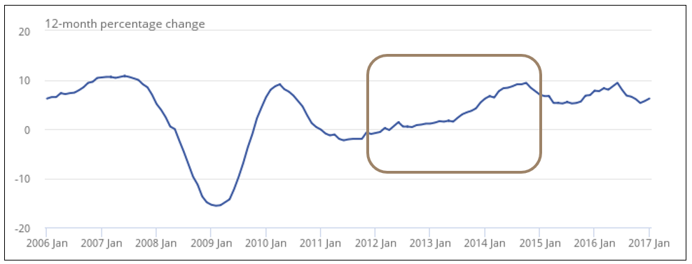

Appendix 2: Best and Worst Scenarios

House Price Increase Rate

Inclusive

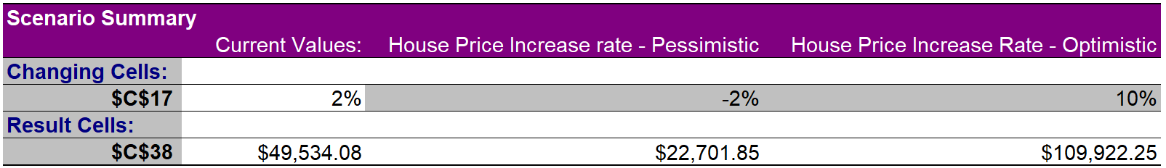

Non-inclusive

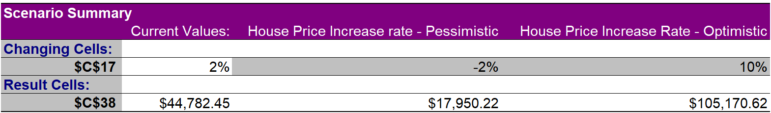

Property Tax

Inclusive

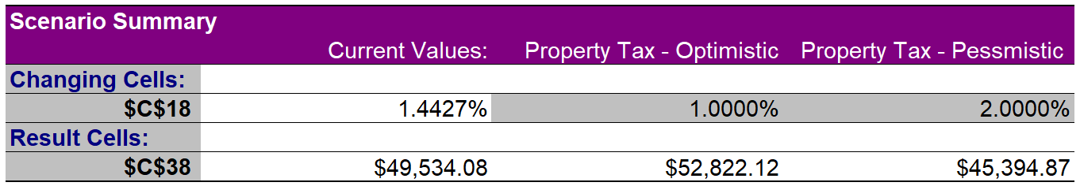

Non-inclusive

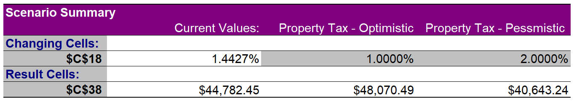

Appendix 3: Break even Analysis

Inclusive

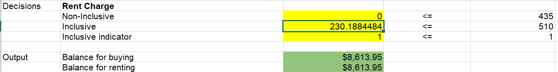

Non-inclusive

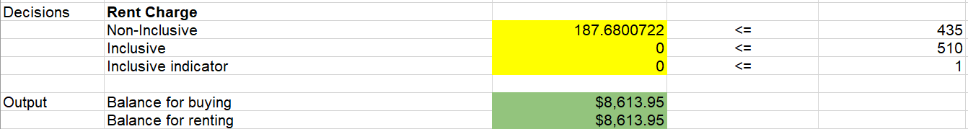

Appendix 4: Break even Analysis

Local optimization

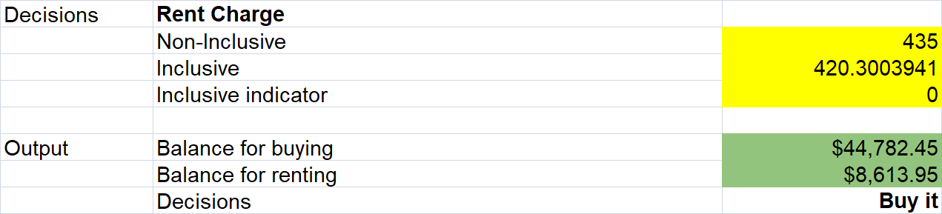

Global optimization

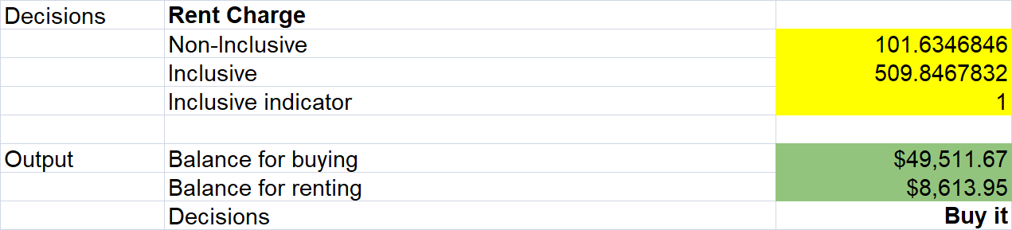

Appendix 5: Sensitivity Analysis

Tornado chart

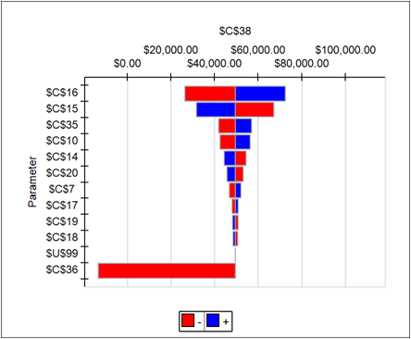

Sensitivity analysis on the change of house price increase rate

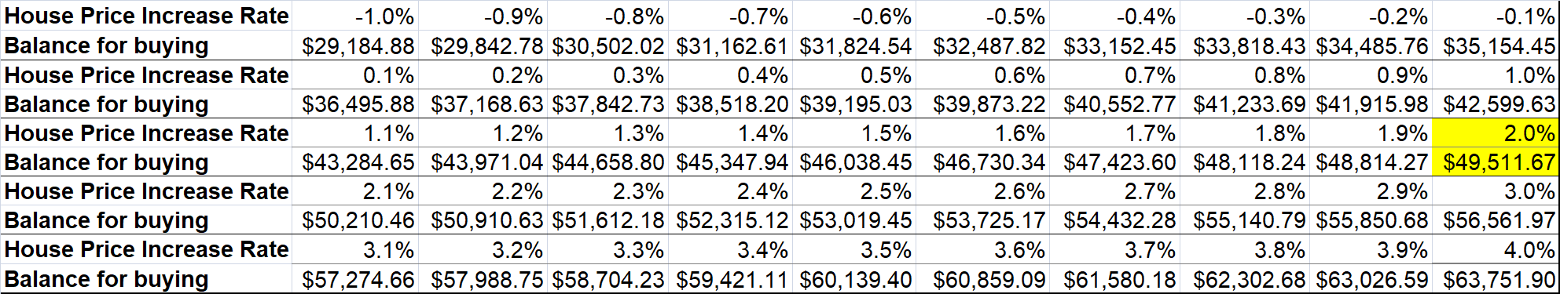

Appendix 6: Risk analysis

Chance of a roommate drop off (Figure 6a)

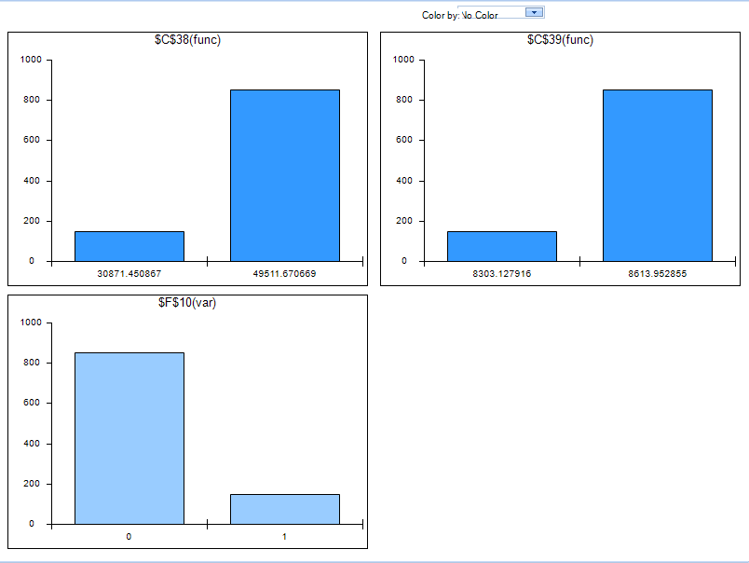

Bank interest rate fluctuations (Figures 6b)

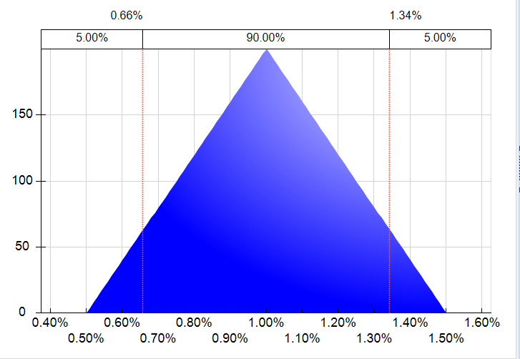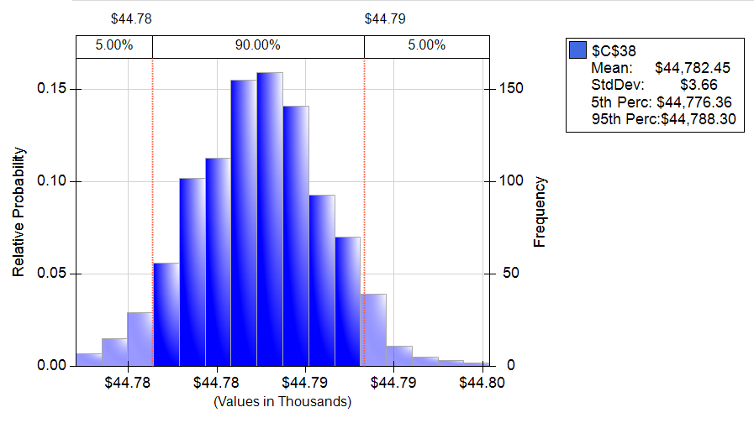

Utilities price fluctuations (Figure 6c)

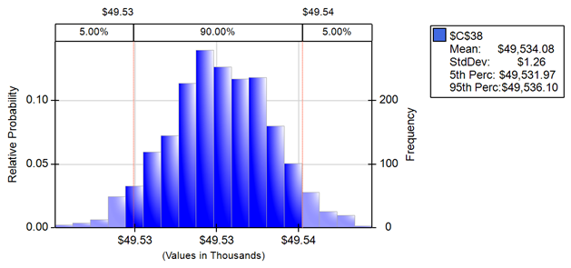

House price increase rate fluctuations (Figure 6d)

